全国绿色矿山名录管理系统

（矿业权人）
用户手册

Management Information System for National Directory of Green Stone Mines
(Mining Right Owners)
User's Manual

自然资源部矿产资源保护监督司
自然资源部信息中心
2020年06月

Department of Mineral Resources Protection and Supervision, Ministry of Natural Resources
Information Center of the Ministry of Natural Resources
June 2020

第1章

1.1

1.2

1.3

第2章

2.1

2.2

第3章

3.1

3.2

3.3

3.4

3.5

3.6

3.7

3.8

3.9

目录

引言.................................................................................................................1

系统简介.....................................................................................................................1

本书适用对象.............................................................................................................1

系统主要功能.............................................................................................................1

系统登录.........................................................................................................2

登录系统.....................................................................................................................2

系统首页.....................................................................................................................3

系统操作.........................................................................................................8

预申报.........................................................................................................................8

新设...........................................................................................................................11

评价指标体系材料上传...........................................................................................16

修改...........................................................................................................................16

删除...........................................................................................................................17

撤回...........................................................................................................................17

证书下载...................................................................................................................18

流程监控...................................................................................................................19

重置密码...................................................................................................................20

第1章引言
Chapter 1 Introduction

1.1系统简介
1.1 System Introduction

全国绿色矿山名录管理信息系统（以下简称“信息系统”）是按照自然资源部矿产资源保护监督司的要求，根据绿色矿山管理工作的有关规定，面向各级自然资源主管部门、第三方评估机构、矿业权人，开展绿色矿山遴选及在线信息填报的专用软件。系统涵盖了矿业权人申报、管理机关审核、第三方评估机构评估等主要功能。
The Management Information System for National Directory of Green Stone Mine (hereinafter referred to as the "information system") is a special software for green mine selection and online information filling for natural resources departments at all levels, third-party evaluation institutions and mining rights owners in accordance with the requirements of the Department of Mineral Resources Protection and Supervision of the Ministry of Natural Resources and relevant regulations on green mine management. The system covers the main functions of mining right owner declaration, management authority verification, and third-party appraisal.
为便于矿业权人全面了解和使用信息系统，特编写本使用手册。
This manual is specially prepared for mining rights owners to fully understand and use the information system.

1.2本书适用对象
1.2 Target Users
本用户手册适用于全国绿色矿山名录库管理信息系统矿业权人用户。
This User's Manual is applicable to the mining right owners in the Management Information System for National Directory of Green Stone Mine.

本系统的使用人员应具备以下知识：
Users of this system shall have the following knowledge:
1、了解计算机基本知识，熟悉windows系统基本操作；
1. Understand the basic knowledge of computer and be familiar with the basic operation of windows system;
2、绿色矿山管理方面的专业知识；
2. Expertise in green mine management;
3、矿业权管理方面的基本知识。
3. Basic knowledge of mining rights management.

1.3系统主要功能
1.3 Main Functions
系统主要功能包括：
The main functions of the system include:
1）绿色矿山预申报数据录入、编辑和浏览；
1) Entring, editing and browsing of pre-declaration data for green stone mines;
2）绿色矿山申报数据录入、编辑和浏览；
2) Entring, editing and browsing of declaration data for green stone mines;
3）数据检查；
3) Data inspection;
4）重置密码；
4) Password reset;
5）其他功能。
5) Other functions.

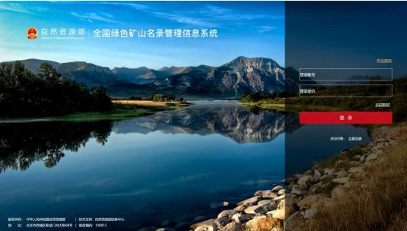
第 2 章 系统登录
Chapter 2 System Login

2.1 登录系统
2.1 System Login
1、在浏览器地址栏输入地址 http://greenmine.mnr.gov.cn，进入登录界

面（如图 2-1），输入用户名和密码， 点击登录按钮， 进入系统首页（如图 2-2）。
1. Input the URL of http://greenmine.mnr.gov.cn in your browser, enter the login interface (Figure 2-1), enter the user name and password, and click the Login button to enter the system home page (Figure 2-2).

图 2-1 系统登录界面
Figure 2-1 System Login Interface

第 2 章 系统登录

2.1 登录系统

1、在浏览器地址栏输入地址 http://greenmine.mnr.gov.cn，进入登录界

面（如图 2-1），输入用户名和密码， 点击登录按钮， 进入系统首页（如图 2-2）。

图 2-1 系统登录界面

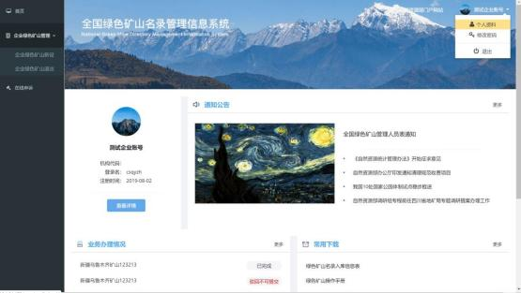
图2-2系统首页
Figure 2-2 System Home Page

2.2系统首页
2.2 System Home Page

2.2.1首页功能
2.2.1 Functions of Home Page
系统首页主要由左侧菜单栏和主显示区两部分组成，其中，菜单栏为系统功能快速入口，包括绿色矿山管理、在线申诉等功能；主显示区包括账户信息、通知公告、业务办理情况、常用下载第三方链接、技术支持信息等。
The system home page is mainly composed of the left menu bar and the main display area. The menu bar offers quick access to system functions, including green mine management, online appeal, etc.; the main display area includes account information, notices and announcements, application status, third-party download links, technical support, etc.

2.2.2个人资料
2.2.2 Personal Information
用户可通过该功能对账户基本信息进行维护更新。
Users can maintain and update basic account information through this function.

操作步骤：
Operation Steps:

1.在【系统首页】界面，点击右上角的个人资料按钮，如图2-3。

1. On the [System Home Page] interface, click the Personal Information button in the upper right corner, as shown in Figure 2-3.

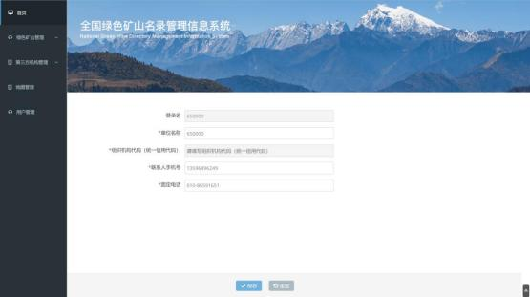
图 2-3 个人资料
2. 进入个
人资料维护界面，如图 2-4：

图 2-4 个人资料修改页面
3. 修改完毕后，点击保存按钮，返回系统首页。

2.2.3 修改密码

通过该功能，可以修改当前登录用户的登录密码。

Figure 2-3 Personal Information
2. Enter the interface of personal data, as shown in Figure 2-4:
Figure 2-4 Modification Page of Personal information
3. After modification, click the Save button to return to the system home page.
2.2.3 Password Change
Users can change the log-in password on this webpage.

图 2-3 个人资料 2. 进入个人资料维护界面，如图 2-4：

图 2-4 个人资料修改页面
3. 修改完毕后，点击保存按钮，返回系统首页。

2.2.3 修改密码

通过该功能，可以修改当前登录用户的登录密码。

操作步骤：
Operation Steps:

1.进入【系统首页】，点击右上角的修改密码按钮，进入【修改密码】界面，如图2-5、2-6。
1. Enter [System Home Page], and click the Change Password button in the upper right corner to enter the [Change Password] interface, as shown in Figures 2-5 and 2-6.

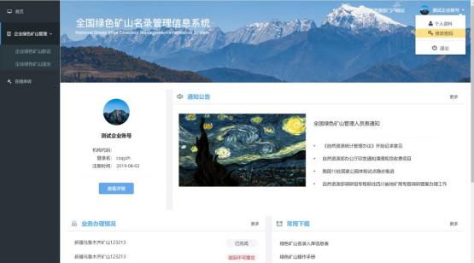

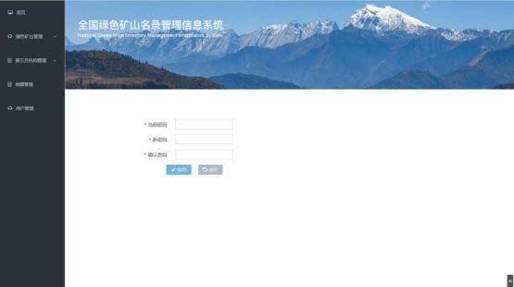
图 2-5 修改密码

图 2-6 修改密码页面
Figure 2-5 Password Change
Figure 2-6 Password Change Page

2.在【修改密码】输入当前密码、新密码，并在确认密码中再次输入新密

码，点击保存按钮，系统弹出修改成功的提示框如图2-7，密码修改成

功。若点击清空按钮，返回到系统首页界面。
2. Enter the current password and new password in [Change Password], enter the new password again in [Confirm Password], and click the Save button. The system will pop up a prompt box indicating that the password is successfully changed, as shown in Figure 2-7. Click the "Back" button to return to the home page of the system.

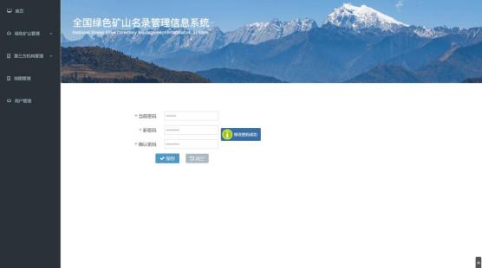
图2-7密码修改成功页面
Figure 2-7 Page of Successful Password Change

2.2.4退出
2.2.4 Exit
操作步骤：
Operation Steps:

1.在【系统首页】，点击右上角的退出按钮，退出系统返回登录界面，如
图2-8。
1. On the [System Home Page], click the Logout button in the upper right corner to exit the system and return to the login interface, as shown in Figure 2-8.

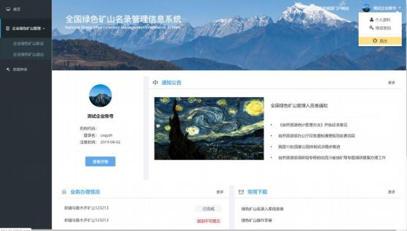

图2-8退出登录
Figure 2-8 Logout

第3章系统操作
Chapter 3 System Operation

3.1预申报
3.1 Pre-declaration
操作步骤：
Operation Steps:

1、点击左侧菜单栏“企业绿色矿山管理-预申报”，如图3-1；
1. Click "Enterprise Green Stone Mine Management-Pre-declaration" on the left menu bar, as shown in Figure 3-1;

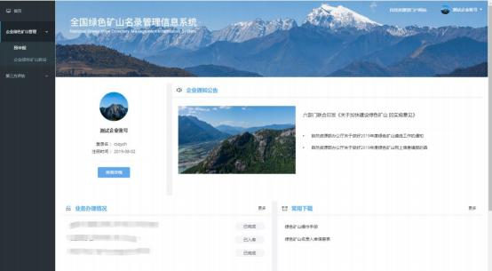

图3-1企业绿色矿山预申报列表
Figure 3-1 List of Pre-declaration for Enterprise Green Stone Mines

2、点击预申报按钮，如图3-2，填写预申报信息。
2. Click the pre-declaration button, as shown in Figure 3-2, and fill in the pre-declaration information.

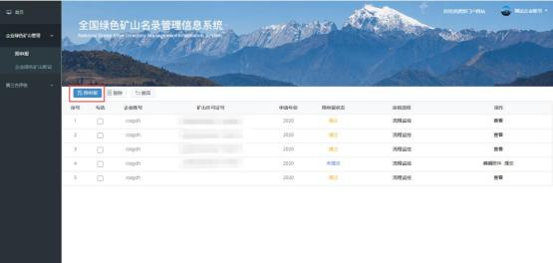

图3-2企业绿色矿山预申报
Figure 3-2 Green Stone Mine Pre-declaration List of Enterprises
3、填写“先决条件”，正确填写所在行政区和矿业权许可证号，如图3-3。绿色矿山申请须以采矿权许可证号为关键字，此处填写完成后，后续操作无需重复填写。
3. Fill in the "prerequisites", and correctly fill in the administrative district and mining right license number, as shown in Figure 3-3. Green mine application shall use the mining right license number as the key word. After filling in the key word, the subsequent operations do not need to be filled in repeatedly.
注：只有所在行政区选择到县一级，对应市县级自然资源主管部门才能看到该
申请。
Note: Only when the administrative district is selected at the county level, can the application only be seen by the corresponding municipal and county-level natural resources departments.

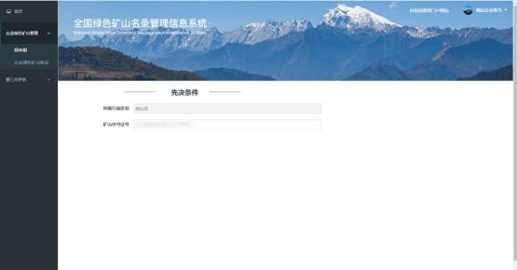
图3-3企业绿色矿山预申报-先决条件
Figure 3-3 Enterprise Green Stone Mine Pre-declaration-Prerequisites

4、按页面要求上传预申报材料，预申报环节附件只支持图片格式，点击右
下角完成按钮返回预申报列表，如图3-4。

4. Upload the pre-declaration documents according to the requirements on the page. Only support image format is supported in the attachments of pre-declaration. Click the Upload button in the lower right corner to return to the pre-declaration list, as shown in Figure 3-4.

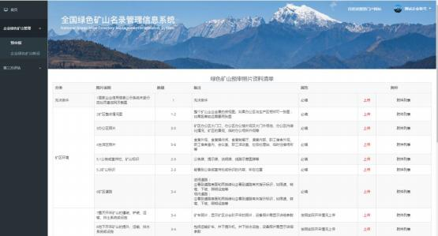
\
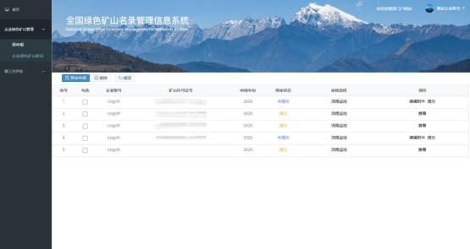
图 3-4 企业绿色矿山预申报材料清单
Figure 3-4 List of Pre-declaration Materials for Enterprise Green Mines
5、“未提交”状态下， 可通过“操作栏”编辑附件按钮进行修改编辑， 确

认无误的， 点击“操作栏”提交按钮， 该预申报提交省级自然资源主管部门审 核，如图 3-5。

5. If the status is “not submitted”, you can modify and edit the entry by clicking corresponding buttons … If you are sure that you input the right data, you can click the "Submit" button in the action bar to submit the-pre declaration to the provincial natural resources authority for review, as shown in Figure 3-5.
图 3-5 企业绿色矿山预申报列表
Figure 3-5 Pre-declaration List of Enterprise Green Stone Mines

3.2新设
3.2 New Application
操作步骤：
Operation Steps:
1、点击左侧菜单栏“企业绿色矿山管理-企业绿色矿山新设”，如图3-6；
1. Click "Enterprise Green Stone Mine Management-New Application of Enterprise Green Stone Mines" on the left menu bar, as shown in Figure 3-6;
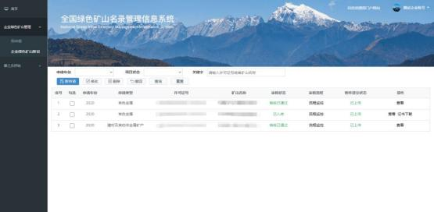
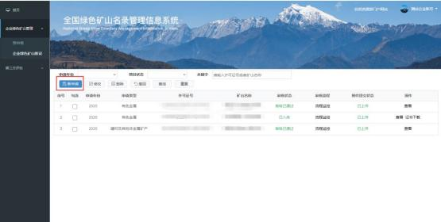
图 3-6 企业绿色矿山新设列表
Figure 3-6 List of New Set-up of Enterprise Green Mines2、点击新申请按钮， 如图 3-7，填写绿色矿山申请信息。
2. Click the New Application button, as shown in Figure 3-7, and fill in the green mine application information.

图 3-7 企业绿色矿山新设申请

图 3-7 企业绿色矿山新设申请

Figure 3-7 New Application for Enterprise Green Stone Mines
3、企业须在通过预申报审核的矿山列表中，选择任一矿山进行绿色矿山申报。选择后，点击确定按钮，完成入库信息表的初始化，点取消返回列表不执行操作，如图3-8。
3. The applicant shall choose any mine from the list of mines that have passed the pre-application review for green mine declaration. After the selection, click the OK button to complete the initialization of the database entry, or click Cancel to return to the list, as shown in Figure 3-8.
注：采矿权许可证号会与“矿业权统一配号系统”和“矿业权人公示公开系
统”实时校验，部分信息会由配号系统直接提取，无需重复填写。
Note: The mining rights license number will be checked in real time with the "Unified Allocation System of Mining Rights" and the "Publicity and Disclosure System of Mining Right Owners". Part of the information will be directly extracted by the allocation system, and there is no need to fill in again.
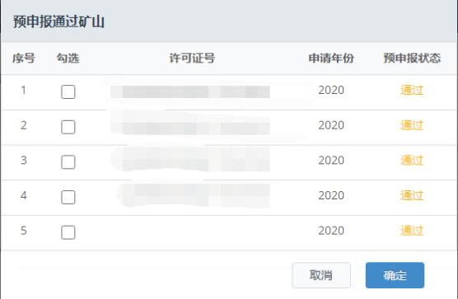
图3-8申报绿色矿山
Figure 3-8 Green Stone Mine Declaration
4、逐次填写“矿山企业基本信息”、“矿山企业联系方式”、“绿色矿山建设指标”、“绿色矿山建设情况”等表格，如图3-9、3-10、3-11、3-12。
4. Fill in the forms of "Profile of Mining Enterprises", "Contact Information ", "Green Stone Mine Construction Indicators", and "Green Stone Mine Construction Status?" successively, as shown in Figures 3-9, 3-10, 3-11, 3- 12.
注：“矿山企业基本信息”页面中，只有所在行政区选择到县一级，对应市县
级自然资源主管部门才能看到该申请。

Note: On the page of "Basic Information of Mining Enterprises", the application can only be seen by the corresponding natural resources authorities at the municipal or county level if the administrative district where the mining enterprise is located is selected at the county level.

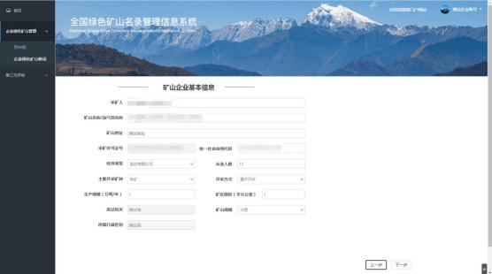

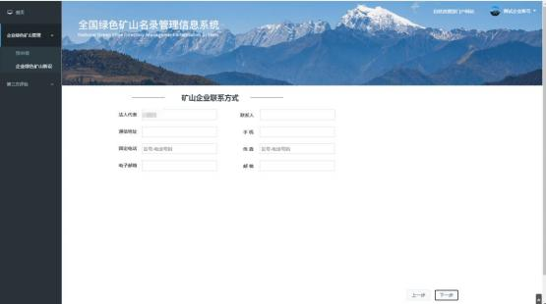
Figure 3-9 Basic information of Mining Enterprises
Figure 3-10 Contact Information of Mining Enterprises
图 3-9 矿山企业基本信息

图 3-10 矿山企业联系方式

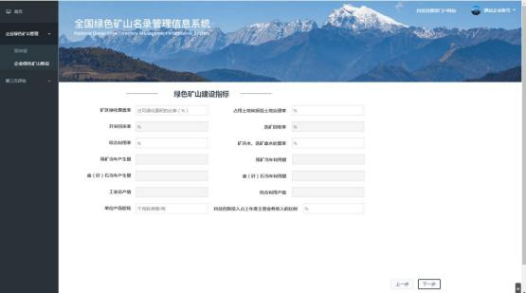

图 3-11 绿色矿山建设指标
Figure 3-11 Green Stone Mine Construction Indicators

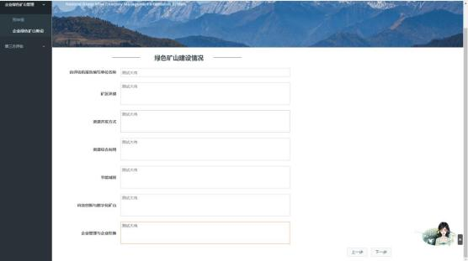
图 3-11 绿色矿山建设指标

图 3-12 绿色矿山建设情况

5、上传相关附件，包括 PDF 文件、图片 、视频文件， 如图 3-13，其中， PDF 文件和图片每个大小不超过 10M，数量不超过 10 个，视频文件每个不超过 100M， 数量不超过 5 个。

图 3-12 绿色矿山建设情况
Figure 3-12 Green Stone Mine Construction
5、上传相关附件，包括 PDF 文件、图片 、视频文件， 如图 3-13，其中， PDF 文件和图片每个大小不超过 10M，数量不超过 10 个，视频文件每个不超过 100M， 数量不超过 5 个。
5. Upload relevant attachments, including PDF files, images and videos, as shown in Figure 3-13. The size of each PDF file and image shall not exceed 10 M, and the total number of files shall not exceed 10. The size of video files shall not exceed 100 M, and the number shall not exceed 5.

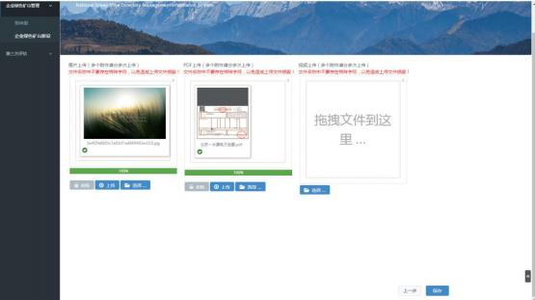
图 3-13 附件

Figure 3-13 Attachments

6、点击保存按钮，返回列表。
6. Click the Save button to return to the list.

7、在申请列表中，点击提交按钮弹出提示框，点击确认按钮，该申请将提交至省级自然资源主管部门，如图 3-14。
7. In the application list, click the Submit button to pop up a prompt box, and click the Confirm button to submit the application to the provincial natural resources authority, as shown in Figure 3-14.

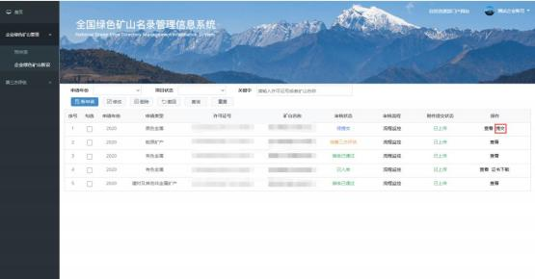
图 3-13 附件

6、点击保存按钮，返回列表。

7、在申请列表中，点击提交按钮弹出提示框，点击确认按钮，该申请将 提交至省级自然资源主管部门，如图 3-14。

图 3-14 提交

3.3评价指标体系材料上传
3.3 Upload Documents of Evaluation Indicators System
1、点击左侧菜单栏“第三方评估-评价指标体系评分表”，如图3-15；
1. Click "Third Party Evaluation- Scoring Table of Evaluation Indicator System" on the left menu bar, as shown in Figure 3-15;
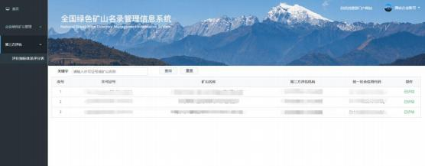

图3-15评价指标体系评分
Figure 3-15 Scoring of the Evaluation Indicator System
2、已提交“新设”申请的矿山，点击“操作栏”材料上传按钮，进入评
价指标材料上传页面；
2. For mines that have been submitted the application of "new set-up", click the button of "Upload Supporting Documents" on the action bar to enter the upload page of evaluation Indicator documents;
3、按照评价指标列表，自愿、如实对照相应指标项上传相关材料，作为第三方评估过程中的佐证材料。
3. According to the evaluation indicator list, upload relevant documents according to the corresponding indicator items voluntarily and truthfully as supporting documents in the third-party evaluation process.

3.4修改
3.4 Modification

对于未提交的申请，可通过该功能进行信息修改。
改按钮，进入信息编辑页面，如图3-16。

For un-submitted applications, you can modify the information through this function. Select a entry and click the Modify button to enter the information editing page, as shown in Figure 3-16.

勾选一条记录，点击修

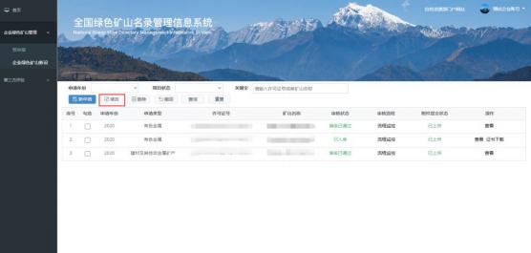
图3-16信息修改
Figure 3-16 Information Modification

3.5删除
3.5 Deletion
对于未提交的申请，可通过该功能进行删除。勾选一条记录，点击删除按
钮，完成删除操作，如图3-17。
For un-submitted applications, you can delete the applcation through this function. Select a record and click the Delete button, as shown in Figure 3-17.
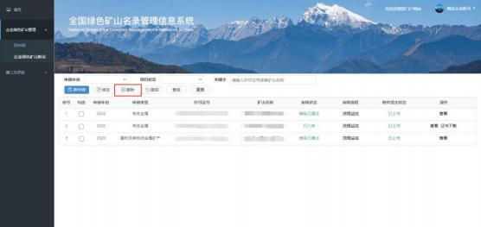
图3-17删除
Figure 3-17 Deletion

3.6撤回
3.6 Withdrawal

对于已提交未审核的申请，可通过该功能进行撤回。撤勾选列表里的一条
记录，点击撤回按钮，可将该条记录还原为未提交状态，如图3-18。

Applications that have been submitted but not approved can be withdrawn through this function. Select a record in the list and click the Withdraw button to restore the record to the un-submitted state, as shown in Figure 3-18.

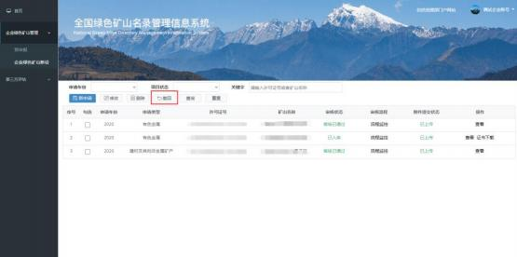

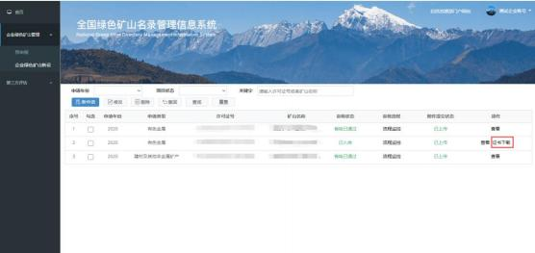
图 3-18 撤回

3.7 证书下载

矿山申请审核通过后， 申请列表中该条记录的操作栏会出现证书下载按
钮，点击该按钮可以下载绿色矿山证书。 如图 3-19。

图 3-19 证书下载

3.8流程监控
3.8 Application Status Monitoring
在申请列表页面，点击流程监控，如图3-20，可查看该申请的办理流程，包括操作人和操作时间，如图3-21。
On the application list page, click Process Monitoring, as shown in Figure 3-20, to view the application process, including the operator and operation time, as shown in Figure 3-21.
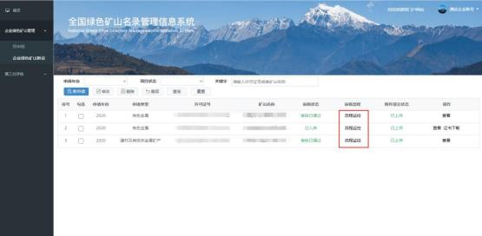

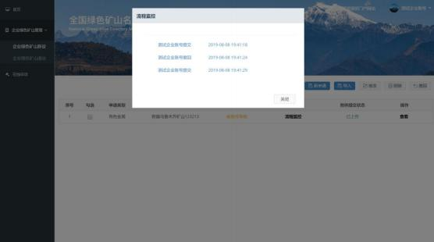
图 3-20 流程监控

图 3-21 流程监控页面

3.9重置密码
3.9 Password Reset
矿山企业如果忘记登陆密码，可通过如下三种方式重置密码。
If a mining enterprise forgets its login password, it can reset it in the following three ways.

3.9.1通过“矿业权人勘查开采信息公示系统”重置密码
3.9.1 Resetting the Password through the "Information Disclosure System for Exploration and Exploitation by Mining Rights owners"
矿山企业在“矿业权人勘查开采信息公示”中修改密码后，“全国绿色矿山名录管理信息系统”可实时获取修改后的密码，直接用修改后的密码登录即可。
After a mining enterprise changes its password in the "Information Disclosure System for Exploration and Exploitation by Mining Rights owners", the "Management Information System for National Directory of Green Stone Mine" can obtain the modified password in real time, and log in directly with the modified password.

3.9.2通过省级自然资源主管部门重置密码
3.9.2 Resetting the Password through the Provincial Natural Resources Authority
省级自然资源主管部门拥有重置密码权限，可联系相关负责同志，通过“全国绿色矿山名录管理信息系统”相关功能，重置企业密码为初始密码。
The provincial natural resources authority has the permission to reset the password, and can contact the relevant responsible personnel to reset the enterprise password to the initial password through the relevant functions of the "Management Information System for National Directory of Green Stone Mine".

3.9.3通过部信息中心管理员重置密码
3.9.3 Resetting the Password through the Administrator of the Department Information Center
可联系部信息中心管理员重置企业密码为初始密码。
You can contact the administrator of the department information center to reset the enterprise password to the initial password.

